Screening Module Approach

TOC

High Level Architecture
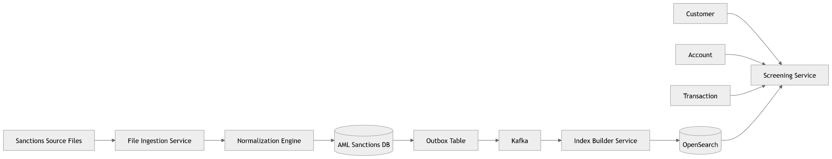

Database Design

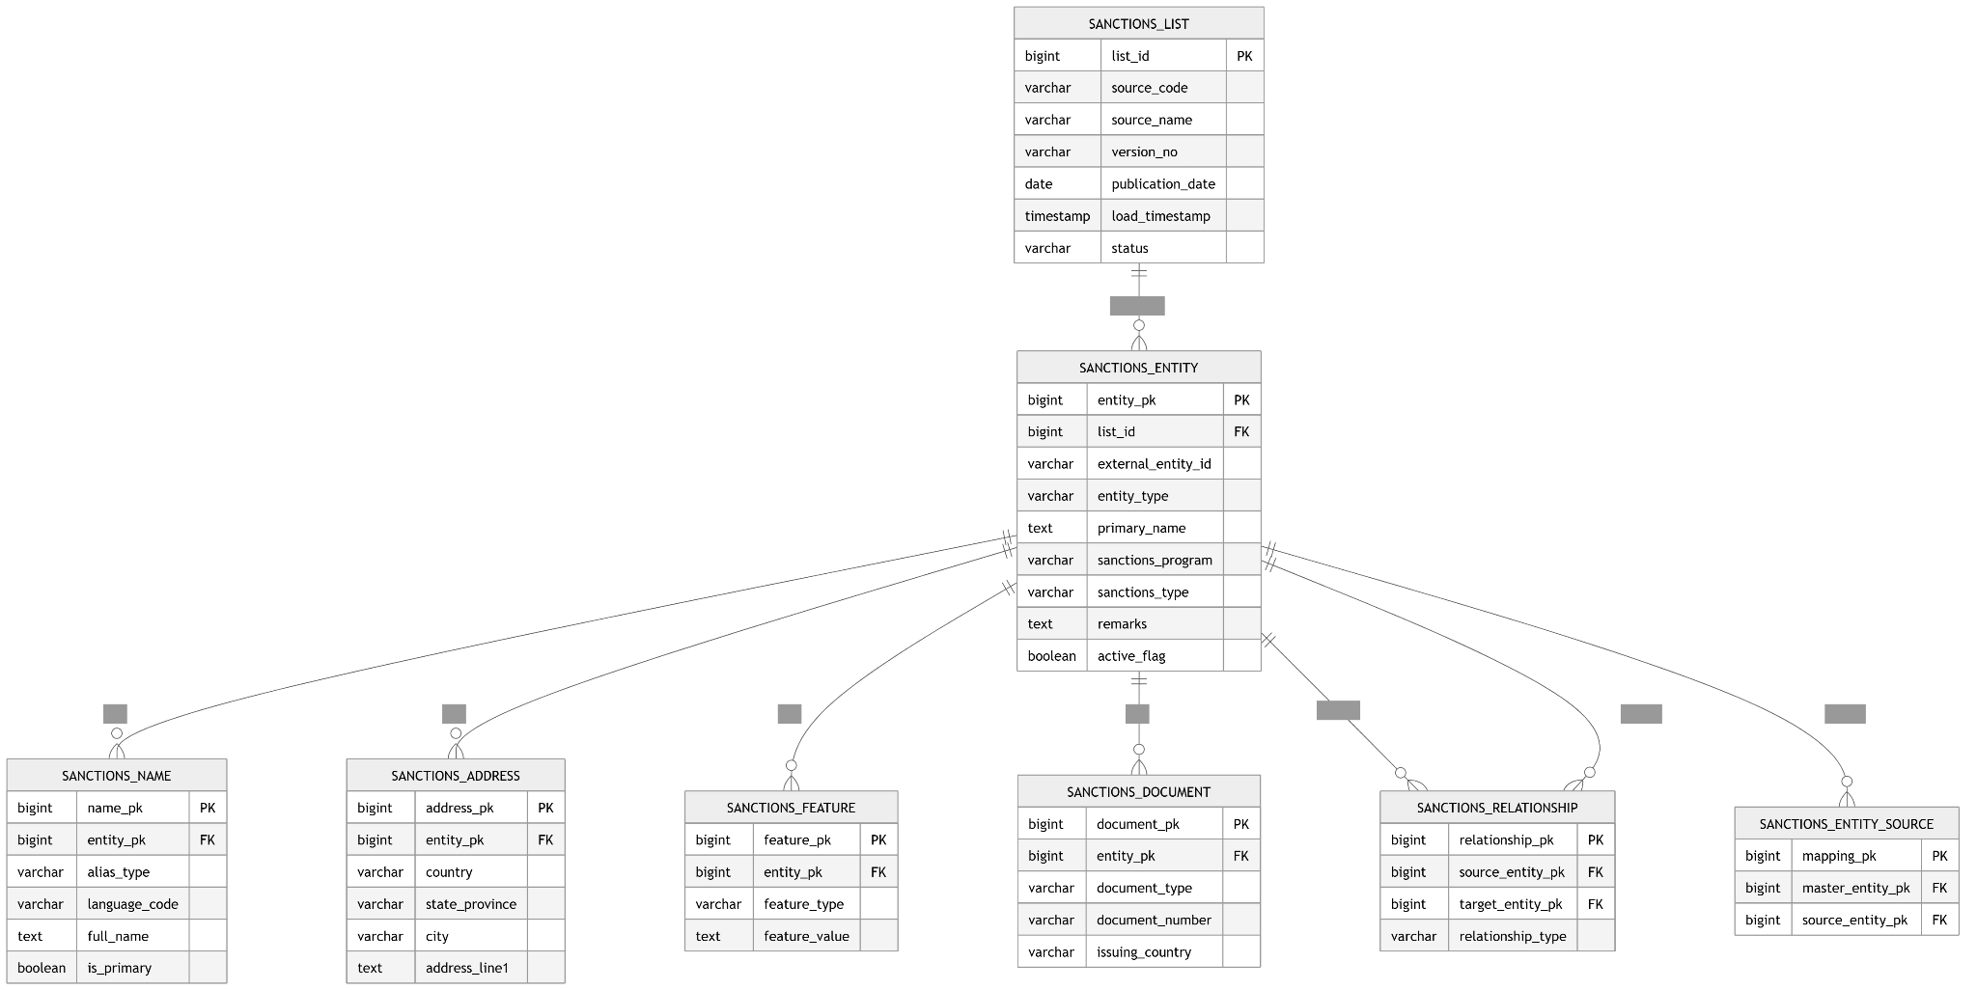

1. sanctions_list
Stores source information.
CREATE TABLE sanctions_list (
list_id BIGSERIAL PRIMARY KEY,

source_code VARCHAR(50),
source_name VARCHAR(500),

version_no VARCHAR(100),

publication_date DATE,

load_timestamp TIMESTAMP,

status VARCHAR(20)
);

list_id | source_code
1 | OFAC_NON_SDN
2 | OFAC_SDN
3 | UN
4 | EU
5 | UK_HMT

2. sanctions_entity
Master entity table.
CREATE TABLE sanctions_entity (
entity_pk BIGSERIAL PRIMARY KEY,

external_entity_id VARCHAR(200),

list_id BIGINT,

entity_type VARCHAR(50),

primary_name TEXT,

sanctions_program TEXT,

sanctions_type TEXT,

legal_authority TEXT,

remarks TEXT,

active_flag BOOLEAN,

created_at TIMESTAMP,
updated_at TIMESTAMP
);

Entity Types
INDIVIDUAL
ORGANIZATION
VESSEL
AIRCRAFT
ADDRESS
CRYPTO_WALLET
UNKNOWN

3. sanctions_name
Stores aliases.
CREATE TABLE sanctions_name (

name_pk BIGSERIAL PRIMARY KEY,

entity_pk BIGINT,

alias_type VARCHAR(50),

language_code VARCHAR(20),

script VARCHAR(50),

full_name TEXT,

first_name VARCHAR(500),

middle_name VARCHAR(500),

last_name VARCHAR(500),

is_primary BOOLEAN,

low_quality BOOLEAN
);

4. sanctions_address
CREATE TABLE sanctions_address (

address_pk BIGSERIAL PRIMARY KEY,

entity_pk BIGINT,

country VARCHAR(100),

state_province VARCHAR(200),

city VARCHAR(200),

postal_code VARCHAR(100),

address_line1 TEXT,

address_line2 TEXT,

address_line3 TEXT
);

5. sanctions_feature
Generic EAV model.
CREATE TABLE sanctions_feature (

feature_pk BIGSERIAL PRIMARY KEY,

entity_pk BIGINT,

feature_type VARCHAR(100),

feature_value TEXT,

is_primary BOOLEAN,

reliability VARCHAR(50),

from_date DATE,

to_date DATE
);

Examples:

feature_type | value
DOB | 1962
NATIONALITY | RUSSIA
PLACE_OF_BIRTH | MOSCOW
GENDER | MALE

6. sanctions_document
CREATE TABLE sanctions_document (

document_pk BIGSERIAL PRIMARY KEY,

entity_pk BIGINT,

document_type VARCHAR(100),

document_number VARCHAR(500),

issuing_country VARCHAR(100),

issuing_authority VARCHAR(500),

issue_date DATE,

expiry_date DATE,

valid_flag BOOLEAN
);

7. Sanctions_relationship
CREATE TABLE sanctions_relationship (

relationship_pk BIGSERIAL PRIMARY KEY,

source_entity_pk BIGINT,

target_entity_pk BIGINT,

relationship_type VARCHAR(100),

effective_from DATE,

effective_to DATE
);

Examples:
OWNED_BY
CONTROLLED_BY
ACTING_FOR
SUBSIDIARY_OF
DIRECTOR_OF

8. sanctions_raw_record

Useful for audit.
CREATE TABLE sanctions_raw_record (

raw_pk BIGSERIAL PRIMARY KEY,

list_id BIGINT,

source_file_name VARCHAR(500),

source_record JSONB,

load_timestamp TIMESTAMP
);

OpenSearch Optimized View
For screening, do NOT search normalized tables.
Create a denormalized document.
{
"entityId": "9639",

"entityType": "INDIVIDUAL",

"primaryName": "HANIYA ISMAIL ABDUL SALAH",

"aliases": [
"HANIYA ISMAIL",
"HANIYYA ISMAEEL"
],

"addresses": [
{
"country":"Palestinian",
"state":"Gaza"
}
],

"dobs":[
"1962"
],

"nationalities":[
"PALESTINIAN"
],

"documents":[
{
"type":"PASSPORT",
"number":"123456"
}
],

"listSource":"OFAC_NON_SDN",

"sanctionPrograms":[
"NS-PLC"
]
}

